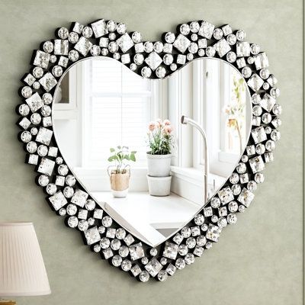**Elegant Heart Mirrors for Warm, Personal Spaces**

A symbol of love, warmth, and affection, **Heart Mirrors** bring a delightful sense of personality and emotion to your interiors. Their gentle curves and iconic shape create a feeling of comfort and intimacy, making them perfect for bedrooms, dressing areas, or cozy nooks where emotion meets design. Whether you’re expressing romance or simply adding a playful touch, heart-shaped mirrors are a beautiful way to reflect your unique taste.

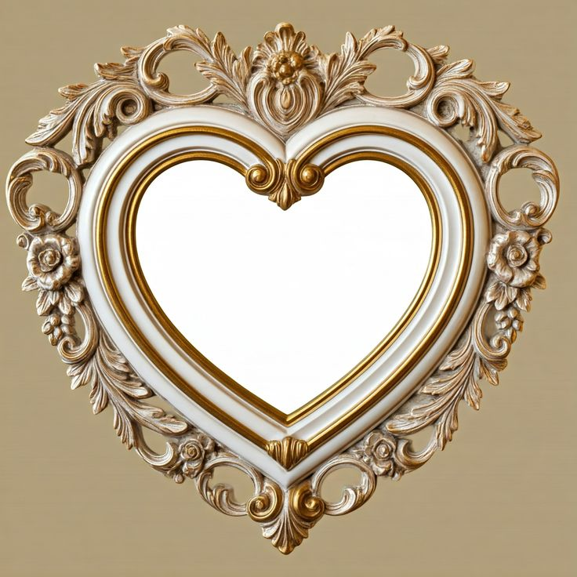Crafted with care and character, our Heart Mirrors come in a range of styles — from minimalist metal-framed designs to vintage-inspired ornate borders and pastel-toned finishes. Each piece is made using premium, distortion-free glass to provide a clear and lasting reflection. Their charming shape adds softness to rigid spaces and serves as an expressive focal point on any wall.

These mirrors are not just decorative, they tell a story — whether hung solo as a statement of self-love or combined with other mirrors in a gallery-style layout. They blend beautifully into boho, romantic, and even eclectic home aesthetics, offering both function and heartfelt flair.

Add a mirror that speaks to the soul — with a heart-shaped design that reflects warmth, style, and emotion.